**Problem Statement/ Case Study (If applicable)**

1. **Bank Account Management System:**
   * Funds Bank needs an application to feed new Account Holder information. AccountHolder will be a person. There are two types of accounts such as SavingsAccount, CurrentAccount.
2. **Employee Medical Insurance Scheme:**
   * By default, all employees in an organization will be assigned with a medical insurance scheme based on the salary range and designation of the employee. Refer the below given table to find the eligible insurance scheme specific to an employee.

|  |  |  |
| --- | --- | --- |
| **Salary** | **Designation** | **Insurance scheme** |
| >5000 and < 20000 | System Associate | Scheme C |
| >=20000 and <40000 | Programmer | Scheme B |
| >=40000 | Manager | Scheme A |
| <5000 | Clerk | No Scheme |

4.1: Refer the case study and create Account Class as shown below in class diagram. Ensure minimum balance of INR 500 in a bank account is available.

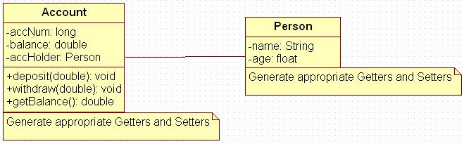

**Figure 14: Association of person with account class**

1. Create Account for smith with initial balance as INR 2000 and for Kathy with initial balance as 3000.(accNum should be auto generated).
2. Deposit 2000 INR to smith account.
3. Withdraw 2000 INR from Kathy account.
4. Display updated balances in both the account.
5. Generate toString() method.

4.2: Extend the functionality through Inheritanceand polymorphism (Maintenance)

Inherit two classes Savings Account and Current Account from account class. Implement the following in the respective classes.

1. Savings Account
   1. Add a variable called minimum Balance and assign final modifier.
   2. Override method called withdraw (This method should check for minimum balance and allow withdraw to happen)
2. Current Account
   1. Add a variable called overdraft Limit
   2. Overridemethod called withdraw (checks whether overdraft limit is reached and returns a boolean value accordingly)

5.1: Refer the case study and create an application for that requirement by creating packages and classes as given below:

**a) com.mp.eis.bean**

In this package, create “Employee” class with different attributes such as id, name, salary, designation, insuranceScheme.

**b) com.mp.eis.service**

This package will contain code for services offered in Employee Insurance System. The service class will have one EmployeeService Interface and its corresponding implementation class.

**c)** **com.mp.eis.pl**

This package will contain code for getting input from user, produce expected output to the user and invoke services offered by the system.

The services offered by this application currently are:

1. Get employee details from user.
2. Find the insurance scheme for an employee based on salary and

designation.

1. Display all the details of an employee.

5.2: Use overrides annotation for the overridden methods available in a derived class of an interface of all the assignments.

5.3: Refer the problem statement 4.1. Modify account class as abstract class and declare withdraw method.